

`

TOM Integration

Interface Specification
Transfer Information for PBS Orders
In Intermediate Data Storage
From RMS to IDS

[J115]

Project BEN Code: | W60416
Author: | Supriyo Chakraborty
Date: | 15/02/2007
Version: | 0.1
Status: | Draft
Modified By:
Reviewed By: | Sankar G

Change Record

Author | Date | Version | Change Reference, description
Supriyo Chakraborty | 15/02/2007 | 0.1D | Draft

Reviewers

Name | Date | Version | Position
Sankar G | 16/02/2007 | 0.1D | Draft

At least one reviewer is required.

Sign-Off

By signing this form, I understand and agree with the contents of this document.

Business Owner/Customer | Rob McDonagh
Position | Solution Architect
Signature | <Physical signature or via email approval>
Date | dd/mm/yyyy (<version signed off>)

Distribution List

Name | Date of Issue | Version
Adrian Hinks | <Issue Date> | <Version No>
David Onyett
Venkateswara Rao
Rob McDonagh

Document Source

Related Documents:
- rib-120-intg\Documentation WIP\Integration Bus\12.0\Integration Guide\XML\TsfDesc.xsd

Information Architecture Context diagram
Will be provided

Mapping spreadsheet
J115-Transfer Information to IDS Mapping Document
Table of Contents
1 Introduction 6
1.1 Purpose of Document 6
1.2 Background 6
1.3 Scope 6
2 Description and Requirements for the End-to-End Interface 7
2.1 Description of the End-to-End Interface 7
2.2 Architecture 9
2.3 Requirements for the End-to-End Interface 9
3 Processing required in an Extract-Stage of the interface 10
3.1 Scope 10
3.2 Source Message Schema 10
3.3 Message Transport Details 11
3.4 Naming and Configuration 11
3.5 Environment and Security Context 12
4 Processing required in the Messaging Stage of the interface 13
4.1 Scope 13
4.2 Data Validation 13
4.3 Filtering 13
4.4 Mapping 13
4.5 Target Message Schema 13
4.6 Message Format 14
4.7 Message Transport Details 14
4.8 Naming and Configuration 15
4.9 Environment and Security Context 15
4.10 Non-Functional Requirements 15
5 Processing required in the <third stage of the interface> 16
5.1 Scope 16
5.2 Data Validation 16
5.3 Filtering 16
5.4 Mapping 16
5.5 Target Message Schema 16
5.6 Message Transport Details 16
5.7 Environment and Security Context 16
6 Testing Deliverables 17
7 Deployment 18
8 Assumptions and Outstanding Issues 19
8.1 Assumptions 19
8.2 Outstanding Issues 19
Appendix A Volumes 20
Appendix B Glossary 21
Appendix C Document Control 22

Introduction

Purpose of Document
The purpose of this document is to describe the interfacing requirements w.r.t the Transfer Details for Pick by Stores (PBS) Orders between Oracle Retail Merchandising System (ORMS) and Integrated Data Store (IDS). The necessity for storing the information in Integration layer is to reference Transfer Order Number and pickup the Original Store Order Quantity when the (Bill of Laden) BOL data sent back to GFO by other interfaces in the loop.

The document is sufficiently technical in nature to allow a developer to build an actual interface. Additionally the document contains detail that might sit logically within a Technical System Design (TSD) document, but is contained here for expediency. There is therefore no associated TSD for this interface.

This interface is required for both US and Turkey implementations.

Background
As part of Tesco Operating Model program, there is requirement to bridge the functionalities of enterprise applications including ORMS and IDS. To achieve this functionality, high level process flow architecture has been designed and approved by Tesco Enterprise Architecture team. As part of this process flow architecture there is a set of interfaces that has been identified to be developed to store Transfer Details coming from ORMS, in IDS for PBS Orders.

Scope
The Interface Specification covers:

- audit requirements across the interface
- security requirements across the interface
- timing/frequency requirements or constraints
- support requirements
- archiving
- the data format to be used for the interface at each stage (e.g. xml messages)
- the normal processing required at each stage
- recovery from failure required at each stage
- volumes.

Note that it is Tesco strategy to avoid placing any business logic in integration layer processing.

Description and Requirements for the End-to-End Interface

Description of the End-to-End Interface
The interface is to upload the Transfer Details for PBS orders from ORMS into IDS. The Upload is a full upload in nature.

The interface will be governed by BizTalk Orchestration, which expects the Transfer Details for PBS Orders from ORMS in the form of XML message. This message is actually a RIB message, which ORMS is communicating to ORWMS about the Transfer Details. JMS adaptor picks up the RIB message and passes the message to the RIB Dissembler. RIB Dissembler in turn converts the RIB message into standard XML message and delivers the message to BizTalk. On completion of this process BizTalk is expected to upload the Transfer Details into tables in IDS through SQL adaptor.

The interface will make use of the audit and traceability components that are being developed as part of the Operational Framework stream. Developers should put a ‘placeholder’ in their code / configurations as appropriate.

History behind this interface
- Pick by Stores orders are raised by GFO and passed on to ORMS. GFO does not allocate the Transfer Order Number. This job is done by ORMS.
- ORMS makes necessary adjustments to the final order and generates the Transfer Numbers for the transfers and the updated order is sent back to GFO.
- ORMS sends the order information to ORWMS for physical material transfer to stores. The Order Information Message contains Transfer Number, Item Number and Final Order Quantity.
- Upon receiving the ordered materials ORWMS generates the Bill Of Lading (BOL) information and sends the same to GFO. The BOL message contains Transfer Number as Distro Number, ASN Number and BOL Number.

Gap:
- GFO needs the information that what is the original store order quantity against shipped quantity. The BOL data doesn’t carry Original Order quantity information.

Solution:
3. The Transfer Data sent by ORMS to ORWMS is captured and stored in intermediate storage. The data contains Transfer Order Number as well as the Original Order quantity.
4. The BOL message originated from ORWMS would capture the Original Order quantity information from Intermediate storage and sent to GFO.

Following data flow diagram is self explanatory

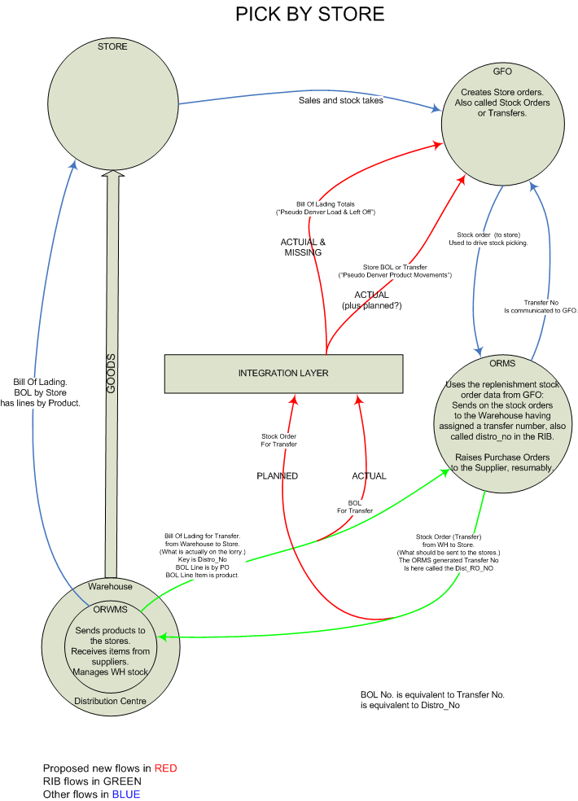

Architecture
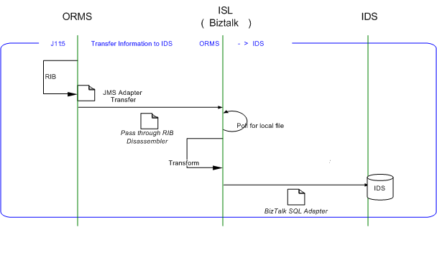

Requirements for the End-to-End Interface

Audit Requirements | The interface will use the components provided by the Operational Framework to satisfy audit requirements.
Security Requirements | The interface executes within a secure private domain. There is no additional security considerations required.
Timing/Cut-off Constraints | To be finalised.
Performance Requirements | The interface should be capable of capturing the RIB message from ORMS side and inserting the information into the tables in IDS before the identified cut-off time. The interface should run on real time basis.
Reliability and Availability Requirements | The interface-run should be atomic in nature. Where it is not possible to implement an atomic nature of interface, appropriate mechanisms should be in place to raise/alert appropriate parties.
Scalability Requirements | N/A - No scalability issues exist.
Operational Support Requirements | No such requirement has been agreed upon at the time of writing this document. However, it is perceived that there would be interface support requirements after go-live date that would require an evaluation.
Likelihood of Change Requirements | There is no such requirement
Cultural/Global Consideration Requirements | N/A
Legal Requirements | N/A
Compliance To Standards Requirements | No compliance exceptions.

Processing required in an Extract-Stage of the interface

Scope
ORMS creates a RIB message for ORWMS, containing Transfer Details for PBS Orders. JMS adaptor picks up the same RIB Message and passes the same message to RIB Dissembler. RIB Dissembler in turn converts the RIB message into standard XML format and delivers the file to BizTalk. Biztalk processes the file and update the IDS tables using SQL Adapter.

Source Message Schema
The source message is created at RMS side is in the form RIB message. The XSD file containing the field definition is embedded below.

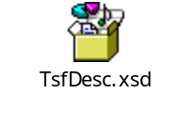
The tabular form of the file with the grouping information is given below:

Field Type | Field Name | Optional | Field Type | Description
TsfDesc | approval_date |  | RIBDate
TsfDesc | approval_id |  | Varchar2(120)
TsfDesc | break_by_distro |  | Varchar2(1)
TsfDesc | context_type |  | Varchar2(6)
TsfDesc | context_value |  | Varchar2(25)
TsfDesc | cust_name |  | Varchar2(40)
TsfDesc | default_order_type |  | Varchar2(9)
TsfDesc | deliver_add1 |  | Varchar2(240)
TsfDesc | deliver_add2 |  | Varchar2(240)
TsfDesc | deliver_city |  | Varchar2(120)
TsfDesc | deliver_country_id |  | Varchar2(3)
TsfDesc | deliver_post |  | Varchar2(30)
TsfDesc | deliver_state |  | Varchar2(3)
TsfDesc | delivery_date |  | RIBDate
TsfDesc | doc_type |  | Varchar2(1)
TsfDesc | exp_dc_date |  | RIBDate
TsfDesc | from_loc |  | Varchar2(10)
TsfDesc | from_loc_tsf_entity |  | Number(10)
TsfDesc | from_loc_type |  | Varchar2(1)
TsfDesc | inv_type |  | Varchar2(6)
TsfDesc | message |  | Varchar2(2000)
TsfDesc | not_after_date |  | RIBDate
TsfDesc | physical_from_loc |  | Number(10)
TsfDesc | physical_to_loc |  | Number(10)
TsfDesc | pick_not_after_date |  | RIBDate
TsfDesc | pick_not_before_date |  | RIBDate
TsfDesc | priority |  | Number(4)
TsfDesc | to_loc |  | Varchar2(10)
TsfDesc | to_loc_tsf_entity |  | Number(10)
TsfDesc | to_loc_type |  | Varchar2(1)
TsfDesc | tsf_no |  | Number(10)
Field Type | Field Name | Optional | Field Type | Description
TsfDesc | tsf_parent_no |  | Number(10)
TsfDesc | tsf_status |  | Varchar2(1)
TsfDesc | tsf_type |  | Varchar2(6)
Begin Sub-Group ‘A’ |  |  | 1:* | TsfDtl will repeat multiple times under TsfDesc
TsfDtl | expedite_flag |  | Varchar2(1)
TsfDtl | inv_status |  | Number(2)
TsfDtl | item |  | Varchar2(25)
TsfDtl | price |  | Number(20)
TsfDtl | priority |  | Number(4)
TsfDtl | selling_uom |  | Varchar2(4)
TsfDtl | store_ord_mult |  | Varchar2(1)
TsfDtl | ticket_type_id |  | Varchar2(4)
TsfDtl | tsf_po_link_no |  | Number(10)
TsfDtl | tsf_qty |  | Number(12)
Begin Sub-Group ‘AA’ |  |  | 1:* | TsfDtlTckt will repeat multiple times under TsfDtl. But in case of Tesco, Sub-group ‘A’ and Sub-sub-group ‘AA’ will be one to one relationship
TsfDtlTckt | comp_item |  | Varchar2(25)
TsfDtlTckt | comp_price |  | Number(20)
TsfDtlTckt | comp_selling_uom |  | Varchar2(4)
End Sub-Group ‘AA’
End Sub-Group ‘A’

Message Format
The source message is in the form of XML file from ORMS

Message Transport Details

Feature | Specification | Additional Information
Source System Name | ORMS
Source Platform / OS | IBM AIX
Source Physical Location
Source Underlying Data Storage Technology | RDBMS
Target System Name | Biztalk 2006
Target Platform / OS | Biztalk 2006 Server
Target Physical Location
Target Underlying Data Storage Technology | File Share
Transfer Function | HTTP (Put/Post) □  HTTPS (Put/Post) □  Message Queue □  FTP □  File Drop(Windows) □  (XCOM) □  JMS adopter ☑
Data Format. | XML ☑  Delimited □  Positional □ | The XML message contains RIB envelop
Decryption/Encryption | RIB Dissembler ☑ | Converts the message into standard XML format
Decompression/Compression | No
Transmission Mode | Synchronous □  Asynchronous ☑  Bulk Data □
Real-time/Scheduled Batch | Not yet decided
Archiving | There is no requirement to archive the messages.
Logging | Logging should occur, such that the message can be recreated if necessary.
Error Handling | Not yet decided  Processing should prevent sending of duplicate messages, unless this occurs during recovery from failure.

Naming and Configuration

Biztalk – 2006
Package Name: Tesco_ TOM_Integration_Tsf_Dtl_for_IDS
BizTalk Procedure
Name | Tesco_ TOM_Integration_Tsf_Dtl_IDS
<Placeholder for other package components/steps>
<Placeholder for other package components/steps>

Environment and Security Context
Account details will be included here once we have visibility of the environments.

Non-Functional Requirements
Not Applicable

Processing required in the Messaging Stage of the interface

Scope
JMS Adapter picks up the RIB message containing the Transfer Details coming from ORMS and passes on to the RIB Dissembler. RIB Dissembler converts the RIB message into standard XML message and delivers the file to Biztalk. Once received BizTalk transforms the file and after transformation, uploads the IDS tables through SQL Adaptor.

Data Validation
Data Validation will be done by the target system.

Filtering
There is no filtering requirement.

Mapping
Mapping document will be provided subsequently.

Target Message Schema

Target Table Structure: The target table structure is given below.

Table Name: Transfer

Sl No | Field Name | Constraints | Type | Description
1 | TransferNo | PK | INTEGER | Transfer Number
2 | TransferStatus |  | VARCHAR2(21) | Transfer Status
3 | FromStoreOrWarehouse | FK | INTEGER | From Location
4 | FromLocationType | FK | CHAR(1) | From Location type
5 | ToStoreOrWarehouse | FK | INTEGER | To Location
6 | ToLocationType | FK | CHAR(1) | To Location type
7 | FromStoreForISTransfer | FK | INTEGER | From Location for Inter Store Transfer
8 | ToStoreForISTransfer | FK | INTEGER | To Store for Inter Store transfer
9 | LastupdateDateTime |  | DATETIME | Last update time

Table name: TransferLine

Sl No | Field Name | Constraints | Type | Description
1 | TransferNo | PK | INTEGER | Transfer Number
2 | PackID | PK | VARCHAR(25) | Pack ID
3 | OriginalTransferQty |  | BIGINT | Original Transfer Quantity
4 | LastUpdateDateTime |  | DATETIME | Last Update Time

Message Format
The source is a RIB message originated from ORMS and gets converted into standard XML message. At the end of the transformation in the integration layer the message gets uploaded into the IDS tables.

There is no message format associated with the output.

4.7 Message Transport Details
For messages destined for RMS system, the following applies.

Feature | Specification | Additional Information
Source System Name | Biztalk 2006
Source Platform / OS | Biztalk 2006 Server
Source Physical Location
Source Underlying Data Storage Technology | RDBMS
Target System Name | IDS
Target Platform / OS
Target Physical Location
Target Underlying Data Storage Technology | RDBMS
Transfer Function | HTTP (Put/Post □  HTTPS (Put/Post) □  Message Queue □  FTP □  File Drop (Windows) □  SQL Adapter ☑
Data Format | XML □  Delimited □  Positional □
Decryption/Encryption | No
Decompression/Compression | No
Transmission Mode | Synchronous □  Asynchronous ☑  Bulk Data □
Real-time/Scheduled Batch | Real-time
Archiving | There is no archiving requirement
Logging  Should logs be kept of all actions? For how long should these be stored? | Logging should occur, such that the message can be recreated if necessary.
Error Handling | Not yet decided  Processing should prevent sending of duplicate messages, unless this occurs during recovery from failure.

Naming and Configuration

Biztalk 2006
Instruction Name: Tesco_TOM_Integration_Tsf_Dtl_File_Delivery
Instruction Details
Description | To be determined
Enabled | True
Type
Operational Window
Schedule | N/A
Enabled | False
Host Details
Account | To be determined
Operational Details
Worker Threads
Priority
Batch Size
Period
Retry Attempts
Timeout
Require Data Send
Exception Management
Treat Fatal Adapter Exception As
Treat Unhandled Exceptions As

Environment and Security Context
Account details will be included here once we have visibility of the environments.

Non-Functional Requirements
On successful delivery of the file to the target system, the audit log should be updated via the Operational Framework pipeline component or adapter (to be determined).

In the event of a failure the file should be written to the failed files location, and an alert should be raised.

Processing required in the <third stage of the interface>

Scope
There is no intermediate staging required for this interface. So this section is not applicable.

Data Validation
Not Required

Filtering
Not Required

Mapping
Not Required

Target Message Schema
Not Required

Message Transport Details
Not Required

Naming and Configuration
Not Required

Environment and Security Context
Not Required

Non-Functional Requirements

Not Required

Testing Deliverables
Unit Test Scripts and test cases are kept at the following location <location>

Deployment

Assumptions and Outstanding Issues

Assumptions
ID | Assumption

Outstanding Issues
ID | Issue | To be addressed by
1 | File naming format to be confirmed | Adrian Hinks
2 | Server Physical Location of the server and file | Adrian Hinks
3 | Error handling | Adrian Hinks
4

- Volumes
- Glossary

Acronym | Term | Description
EAI | Enterprise Application Integration | The process of meeting the data requirements of applications by providing a message based transport from disparate data sources across all forms of enterprise technology.
EAI Layer | Enterprise Application Integration Layer | Refers to the integration services provided to implement EAI. In contrast to the EIA Layer for data services. See below.
EIA | Enterprise Information Architecture | Creation of a strategic single view of data across the enterprise.
Interface | Interface | Many definitions exist for 'interface'. In general, 'interface' refers to the link between a data source and a data target. And there are properties of the interface in this context. However more specifically 'interface' refers to one end of a data link, hence the terms source interface and target interface, and both the source interface and the target interface will have specific properties of their own.
ORMS | Oracle Retail Merchandising System | ORMA is getting installed for TESCO Merchandising operations in US. This system will governs the Merchandising operations; Receive base Master & Transaction data and from other systems and Provide data to next level of operation system as part of Retail systems chain.
IDS | Integrated Data Store | IDS is the data store for information like Product, Supplier, Location etc. The IDS keeps information regarding Transfer to facilitate the functioning of other system modules.
JMS Adapter | JMS Adapter | JMS Adapter is used to pick up RIB message and convert the message into the standard XML format. JMS Adapters are used by BizTalk to pick up such messages.
RIB Dissembler | Retek Integration Bus Dissembler | RIB Dissembler takes the RIB message as input and removes the header and footer from the RIB message and ultimately converts the RIB message into standard XML file.

- Document Control
Change Record

Author | Date | Version | Change Reference, description
Supriyo Chakraborty | 27/12/2006 | 0.1

Related Documents

Author | Date | Version | Title
To be filled

Distribution

Name | Position | Approver/Contributor/Other
Nathan Smith | Enterprise Architect
Adrian Hinks | Engagement Architect
David Onyett | Project Lead
Rob McDonagh | Solution Architect

